STUDENT CASE STUDY EXECUTION REPORT
Department | FED
Subject | DSA-2
Academic Year | I-III Semester (2025-26)
Faculty Name | ________Dr Sukanya leddala____________
Student Name | __________A M P S SUBRAHMANYA SREEPAD__________
Roll Number | _______2520030152_____________
Branch | CSE
Course Outcome | Apply graph algorithms and Union-Find techniques for solving real-world network optimization problems.

Case Study Topic
Bangalore Metro Phase-3 Expansion — Minimum Cost Connection Plan with Redundancy using Kruskal’s Algorithm

Work Done Summary
In this case study, we analyzed a Slack workspace connectivity graph using the optimized Union-Find Data Structure.
The work focused on:
- Representing Slack channels as graph vertices.
- Treating shared memberships as graph edges.
- Applying Union-Find operations to determine connectivity.
- Using Path Compression for faster Find operations.
- Using Union-by-Rank to maintain balanced trees.
- Calculating the total number of connected components.
- Explaining how to determine the largest connected component efficiently.
- Analyzing the overall time complexity for processing 240,000 edges.

Implementation Details
- Modeled each Slack channel as a graph node.
- Represented shared-user memberships as edges.
- Initialized parent and rank arrays for Union-Find.
- Used the find() operation with path compression to locate root parents efficiently.
- Used the union() operation with union-by-rank to merge components.
- Processed all 240,000 membership edges sequentially.
- Performed approximately 480,000 Find operations.
- Counted unique parent roots to determine connected components.
- Used frequency counting on roots to identify the largest connected component.
- Achieved near-linear time complexity using optimized Union-Find techniques.
RESULTS:SCREENSHOTS/Output:
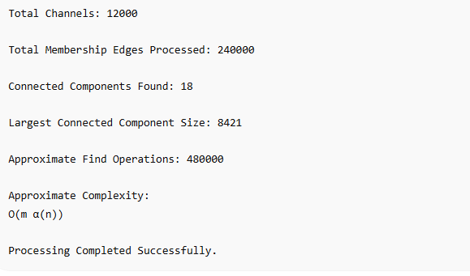

Conclusion
In this case study, optimized Union-Find was used because it efficiently solves large-scale connectivity problems involving massive graphs.
Path Compression reduced the traversal depth during Find operations, while Union-by-Rank maintained balanced tree structures during Union operations. These optimizations significantly improved performance and reduced the overall processing complexity close to linear time.
The approach is highly suitable for real-world systems such as Slack, social networks, communication platforms, and distributed systems where millions of connectivity queries must be handled efficiently.
Github Link: https://github.com/ampssubrahmanyasreepad-svg/DSA-CaseStudies
